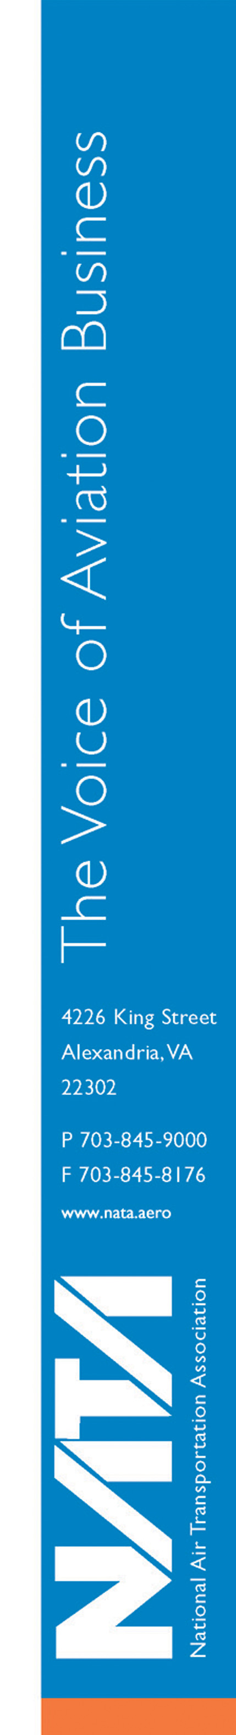
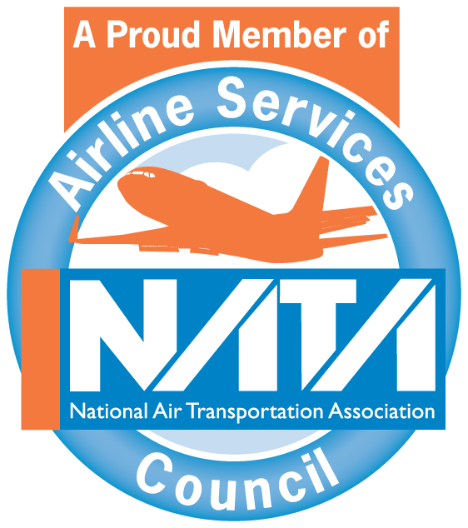

NATA Air Charter Committee
Hilton Mark Center
Alexandria, VA
April 22, 2010

MINUTES

- Welcome and Call to Order
Chairwoman Terri Farish called the meeting to order, and welcomed the attendees. Committee members and guests introduced themselves.

Present were the following members, guests and staff:

Terri Farish, Chairwoman | Chantilly Air
Megan Wolf, Vice Chairwoman | Flight Options
Scott Ashton | Gama Aviation
Dana Carr | Air Trek, Inc.
Clark Earick | Delta AirElite Business Jets, Inc.
Eileen Gleimer | Crowell & Moring LLP
Michael Grossman | Castle Aviation Inc.
Kent Jackson | Jackson, Wade and Blanck LLC
Paul Lange | Law Offices of Paul A. Lange, LLC
Todd Guelich | AirSure Ltd.
Bob Marinace | Key Air
Steve McNeely | Jet Solutions, LLC (alternate for Christopher Page)
Andy Priester | Priester Aviation, LLC
Robert Seidel | Jet Aviation
Guests
Anthony Booth | Sentient
Anthony Ethridge | Sentient
Matt Feinstein | Jet Aviation
Bill Haberstock | Million Air Salt Lake City
Lindsey McFarren | McFarren Aviation Consulting
Frank Milian | ACM Aviation
Brad Schreck | Sentient
Mark Willey | Bridgeford Flying Services
NATA Staff
Eric Byer
Jim Coyne
Russ Lawton
Alison McHugh
Kristin Moore

- Chairwoman’s Remarks
Chairwoman Terri Farish introduced Megan Wolf as the new vice chairwoman of the committee.

- Approval of Minutes
Michael Grossman made the motion to approve the Minutes of the January 13, 2010 teleconference meeting, and Paul Lange seconded the motion.

- Air Charter Safety Foundation Update
Russ Lawton updated the committee on the Air Charter Safety Foundation (ACSF). The ACSF was established three years ago. The Industry Audit Standard (IAS) was launched in 2009 and twenty-four audits were conducted, primarily through an agreement between the ACSF and Executive Jet Management/NetJets. Ten operators audited in 2009 have successfully completed the audit and obtained IAS registration. To date, thirty audits have been scheduled for 2010.

AVSiS is an ACSF-managed safety event reporting and management system for FAA-certificated Part 135 operators and Part 91K-authorized fractional program managers. The ACSF provides it free to any Part 135 or 91K operator. The ACSF is exploring the possibility of the ACSF facilitating an Aviation Safety Action Program (ASAP) for ACSF members. Response from the FAA about such a program has been positive so far, and the ACSF will pursue this concept further in 2010.

- SMS/International Operations Update
Lawton also updated the group on the Safety Management System (SMS) Aviation Rulemaking Committee. A notice of proposed rulemaking (NPRM) will be issued in the future as a result of the group’s work. Lawton doesn’t expect the NPRM until 2012. A few key points were highlighted: The rule will apply to all FAA certificate-holding entities (not pilots) and might include 91K operators. An SMS is not required to fly internationally. Most states are requiring an SMS of operators of aircraft registered in their own country, but not of aircraft registered in other countries.

Flight data monitoring programs have created problems for some operators when flying internationally. Bob Seidel asked if anyone has had problems in France when operating larger aircraft. Lawton explained that the French requirement for flight data monitoring has been in place for five years and the French are starting to enforce it. Seidel asked the association for help with this important issue, as some operators are avoiding France to avoid any problems.

- Broker Update – Andy Priester and Kent Jackson
Andy Priester and Kent Jackson provided an update on concerns regarding brokers and the payment of federal excise taxes (FET). Priester started by asking if a broker collects money for FET from an aircraft operator, but then doesn’t pay, who is liable for the taxes and any resulting penalties? Priester explained that operators have growing concerns that the operator would be found responsible. Jackson said he has been unable to find reported cases of enforcement against an operator when a broker hasn’t paid FET. Eileen Gleimer said new IRS guidance suggests the operator is the proper entity to remit the FET, but since brokers mark up the cost of the transportation the operator has a difficult time determining the correct amount for FET. Farish reported that in recent audits, her company has shown the auditors’ agreements between the operator and the broker that make the broker liable for remitting FET. The group discussed this issue at length. However, it seems that IRS guidance is still inconsistent and is always changing. If an operator decides to allow the broker to submit FET, the operator should have a written agreement with the broker clearly stating the broker’s liability.

- RA-Check Introduction – David Vernon
Dave Vernon introduced NATA’s newest product – RA-Check. RA-Check is an automated risk assessment based on the Turbine Aircraft Operators Subgroup risk assessment matrix. More information can be found at www.nata.aero/racheck. Committee members were very interested in the program, but had questions regarding compatibility with existing scheduling programs. Seidel asked if the risk factors will be updated each year, as the TAOS matrix was developed in 2007. Seidel also asked if NATA would consider developing a risk assessment program for ground operations and aircraft movements.

- TSA Update – Kerwin Wilson, Assistant General Manager of General Aviation Programs
Kerwin Wilson told the group about new General Manager of General Aviation Brian Delauter, who is a pilot with both general aviation and airline experience. Under Delauter’s leadership, the office has established a general aviation outreach program. The office is also still working on the Large Aircraft Security Program (LASP). Wilson said there is no set timeline for the publication of the next proposed rule for the LASP. The Twelve-Five Standard Security Program and the Private Charter Standard Security Program are both being managed in the general aviation office. Wilson also assured the committee that the TSA and Customs and Border Protection are working together to eliminate redundancies and improve consistency between the agencies. Committee members asked the TSA to look at communication issues between offices at the FAA and Flight Service, which can result in lack of communication to operators regarding temporary flight restrictions and other important information.

- Legislative Update
Kristin Moore provided a brief update on the FAA Reauthorization bill. The bill has passed in both the U. S. House of Representatives and the U.S. Senate, except for concerns over a pro-labor issue. As written, the bill would lead to a fuel tax of 35.9 cents per gallon, but should reverse the fuel fraud tax issue that operators have been struggling with for years.
- State Tax Update
Nel Stubbs of Conklin & deDecker called in to update the group on state taxes. Several states have seen changes to their aviation-related taxes in the past year. She also reported that audits have increased in many states, specifically Texas, Arizona, and Florida. Wolf asked if there has been any movement on the assessment of taxes on management fees, particularly for Part 91K operators. An IRS/industry working group is currently discussing the issue, but there has been no change so far.

- Regulatory Issues
Duty/Rest Requirements: Lindsey McFarren reported that at least one Flight Standards District Office has issued a letter to all its Part 135 operators stating that the 10-hour “look back” concept is not an acceptable means of compliance with rest requirements. Jackson said the Part 135 Aviation Rulemaking Committee addressed this issue and it’s time the FAA followed through with those recommendations. Committee members asked how to push the FAA to consider those recommendations. Seidel told the committee that Jet Aviation is using a fatigue-based risk management program and asked if other operators might be interested in using it.

Navigation Database Updates: The group expressed concerns with recent attention to navigation database updates. Some members were unaware of the requirement for a mechanic to perform the update and were allowing pilots to complete the task. NATA is writing a letter asking the FAA for assistance with the issue until rulemaking can be pursued.

- Department of Transportation (DOT) Update – Dayton Lehman
Dayton Lehman told the committee that an NPRM regarding broker activity will be issued in summer 2010. The NPRM is the response to National Transportation Safety Board recommendations following a Part 135 accident in Montrose, Colorado. The committee expressed concerns about brokers who go out of business while holding payment for trips. Lehman also reminded the group of the rules regarding disabled air travelers, which were issued on May 13, 2008, and implemented on May 13, 2009, and apply to aircraft with 19 or more seats as originally designed. Lehman said the DOT might host a forum for concerned operators. One committee member reported brokers beginning again to ask operators to remove all logos and markings from aircraft. Lehman told the group to contact him with those concerns and he will follow up.

- New Business
Runway Braking Action concern: Grossman told the group about an issue he has faced regarding runway braking action. An advisory circular states that if runway action is nil, the airport must close the runway. If there are two reports of poor braking action, closing the runway is not required but is at the airport’s discretion. However, one region has told airports they MUST close the runway after two reports of poor braking action. Grossman also gave a copy of the advisory circular and region’s letter to NATA’s France.
Legal Services: Dana Carr gave the group a quick overview of the AOPA legal services program that covers pilots and asked if members would be interested in NATA developing a similar program for member operators. The group discussed it briefly. Paul Lange urged the committee to pursue the concept with caution – it could give the association or an insurance company the power to decide the limits of an operator’s defense. NATA will look into the idea.

- Adjournment
Seidel made the motion for the meeting to adjourn at 1403. Carr seconded the motion, and the meeting was adjourned.

