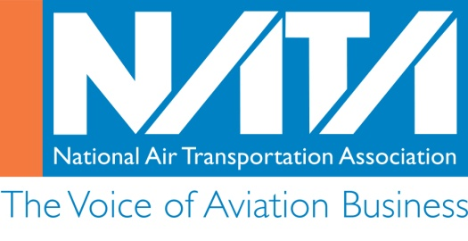
Aviation Maintenance Technician Employer
Recognition Award Program
2017 Award Application Form

Company Information
Date:_________________
Company Name
(as it should appear on certificate):
Name and title of person completing this application:
Company street address:

City, state and zip code:

Telephone Number:

Email Address:

How many total Aviation Maintenance Technicians (AMT) were employed by your
company (either directly or indirectly) in 2016? __________________________
How many of the employed AMTs completed the required 12 hours of qualified training in 2016: _________
Please attach a sheet listing the names of all AMTs who completed the required 12 hours of qualified training in 2016 – NOTE: This application will not be considered without the AMTs’ names attached.

As a company official, I certify that the information contained in this application and attachments is true and that appropriate proof of training is available and will be retained by the company for five (5) years.

Signature:_____________________________________________________ Date:__________________

Printed Name and Title: ___________________________________________________________________
Deadline is March 24, 2017
Please email this completed application to safety1st@nata.aero

